DHS-3979-ENG 11-16

# Notice of Privacy Practices

(Effective Date: November 2016)

**This notice tells how private information about you may be used and disclosed and how you can get this information.**

**Please review it carefully.**

**Why do we ask for this information?**

* In order to determine whether and how we can help you, we collect information:
* To tell you apart from other people with the same or similar name
* To decide what you are eligible for
* To help you get medical, mental health, financial or social services and decide if you can pay for some services
* To decide if you or your family need protective services
* To decide about out-of-home care and in-home care for you or your children
* To investigate the accuracy of the information in your application
* After we have begun to provide services or support to you, we may collect additional information:
* To make reports, do research, do audits, and evaluate our programs
* To investigate reports of people who may lie about the help they need
* To collect money from other agencies, like insurance companies, if they should pay for your care
* To collect money from the state or federal government for help we give you.
* When your or your family's circumstances change and you are required to report the change (see Client Responsibilities and Rights – DHS-4163)

**Why do we ask you for your Social Security number?**

We need your Social Security number to give you medical assistance, some kinds of financial help, or child support enforcement services (42 CFR 435.910 [2006]; Minn. Stat. 256D.03, subd.3(h); Minn. Stat.256L.04, subd. 1a; 45 CFR 205.52 [2001]; 42 USC 666; 45 CFR 303.30 [2001]). We also need your Social Security Number to verify identity and prevent duplication of state and federal benefits. Additionally, your Social Security Number is used to conduct computer data matches with collaborative, nonprofit and private agencies to verify income, resources, or other information that may affect your eligibility and/or benefits.

You do not have to give us the Social Security Number:

* For persons in your home who are not applying for coverage
* If you have religious objections
* If you are not a United States citizen and are applying for Emergency Medical Assistance only
* If you are from another country, in the United States on a temporary basis and do not have permission from the United States Citizenship and Immigration Services to live in the United States permanently
* If you are living in the United States without the knowledge or approval of the U.S. Citizenship and Immigration Services.

**Do you have to answer the questions we ask?**

You do not have to give us your personal information. Without the information, we may not be able to help you. If you give us wrong information on purpose, you can be investigated and charged with fraud.

**With whom may we share information?**

We will only share information about you as needed and as allowed or required by law. We may share your information with the following agencies or persons who need the information to do their jobs:

* Employees or volunteers with other state, county, local, federal, collaborative, nonprofit and private agencies
* Researchers, auditors, investigators, and others who do quality of care reviews and studies or commence prosecutions or legal actions related to managing the human services programs.
* Court officials, county attorney, attorney general, other law enforcement officials, child support officials, and child protection and fraud investigators
* Human services offices, including child support enforcement offices
* Governmental agencies in other states administering public benefits programs
* Health care providers, including mental health agencies and drug and alcohol treatment facilities
* Health care insurers, health care agencies, managed care organizations and others who pay for your care
* Guardians, conservators or persons with power of attorney
* Coroners and medical investigators if you die and they investigate your death
* Credit bureaus, creditors or collection agencies if you do not pay fees you owe to us for services
* Anyone else to whom the law says we must or can give the information.

**What are your rights regarding the information we have about you?**

* You and people you have given permission to may see and copy private information we have about you. You may have to pay for the copies.
* You may question if the information we have about you is correct. Send your concerns in writing. Tell us why the information is wrong or not complete. Send your own explanation of the information you do not agree with. We will attach your explanation any time information is shared with another agency.
* You have the right to ask us in writing to share information with you in a certain way or in a certain place. For example, you may ask us to send health information to your work address instead of your home address. If we find that your request is reasonable, we will grant it.
* You have the right to ask us to limit or restrict the way that we use or disclose your information, but we are not required to agree to this request.
* If you do not understand the information, ask your worker to explain it to you. You can ask the Minnesota Department of Human Services for another copy of this notice.

**What are our responsibilities?**

* We must protect the privacy of your private information according to the terms of this notice.
* We may not use your information for reasons other than the reasons listed on this form or share your information with individuals and agencies other than those listed on this form unless you tell us in writing that we can.
* We must follow the terms of this notice, but we may change our privacy policy because privacy laws change. We will put changes to our privacy rules on our website at: http://edocs.dhs.state.mn.us/lfserver/

Public/DHS-3979-ENG

**What privacy rights do children have?**

If you are under 18, when parental consent for medical treatment is not required, information will not be shown to parents unless the health care provider believes not sharing the information would risk your health. Parents may see other information about you and let others see this information, unless you have asked that this information not be shared with your parents. You must ask for this in writing and say what information you do not want to share and why. If the agency agrees that sharing the information is not in your best interest, the information will not be shared with your parents. If the agency does not agree, the information may be shared with your parents if they ask for it.

**What if you believe your privacy rights have been violated?**

If you think that the Minnesota Department of Human Services has violated your privacy rights, you may send a written complaint to the U.S. Department of Health and Human Services to the address below:

Minnesota Department of Human Services

Attn: Privacy Official

PO Box 64998 St. Paul, MN 55164-0998

___________________________________________

SIGNATURE

_______________

DATE

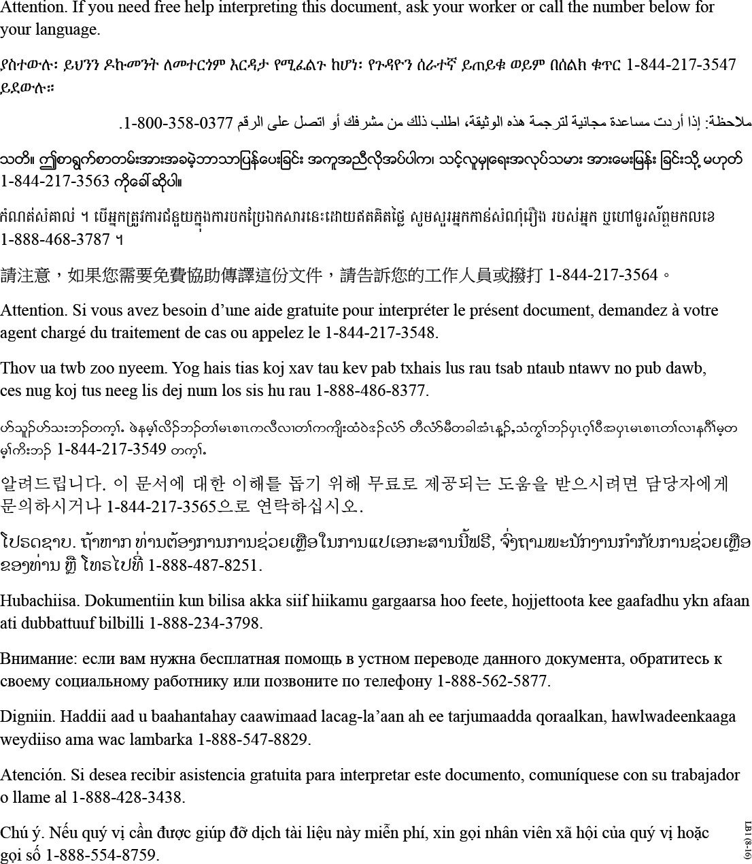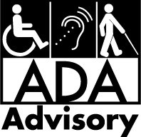

For accessible formats of this

information, ask your county worker.

For assistance with additional equal

access to human services, contact your

county's ADA coordinator.

ADA4 (2-18)